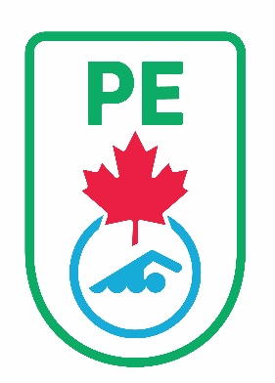
SWIM PEI INC.

2021 Canada Games Team

Selection Registration Form

Please indicate your intention to participate in the 2021 Canada Games Team selection process by completing this form and submitting $60 registration fee by November 25th, 2021. Only registered swimmers will be provided with event / training opportunity information. The completed form can be emailed to swimpei@outlook.com. Payment by cheque can be mailed to the Swim PEI office, 40 Enman Cres., Charlottetown, PE C1E 1E6 or sent by E-transfer to swimpeitreasurer@gmail.com, password should be “2021canadagames”

2021 Canada Games Athlete Eligibility
Olympic:
  - Male swimmers must be born in 2005 or later
  - Female Swimmers must be born in 2006 or later
Paralympic:
- All para swimmers (classes S1-S14) must be born between 1996-2008
Special Olympics
- All Special Olympics Canada registered swimmers must be born between 1996 – 2008.

Canada Games Council – Athlete Eligibility Policy

Canada Games Council – Swimming Technical Package

Swimmer’s Name: Click or tap here to enter text.
Parents or Guardian Name: Click or tap here to enter text.
Preferred email address for Canada Games Communication:
Click or tap here to enter text.
Emergency contact name: Click or tap here to enter text.
Emergency contact phone number: Click or tap here to enter text.

